REPUBLIC OF THE PHILIPPINES
Department of Labor and Employment
REGIONAL OFFICE NO. ________
Public Employment Service Office
___________________________________
SPECIAL PROGRAM FOR EMPLOYMENT OF STUDENTS
(RA 7323, as amended by RAs 9547 and 10917)
SPES Form 2-A

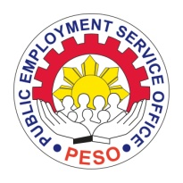

OATH OF UNDERTAKING

I, ____________________________________________, _______ years of age, resident of ________________________________________________________________________, as a SPES beneficiary, do hereby agree and undertake to abide and be bound by the following conditions:

- That I will enroll in any educational or technical vocational (tech-voc) institution to pursue and continue my studies;

- That in the event that I would not be able to enroll, I will inform the DOLE Regional Office, through the Field or Provincial Office concerned, and submit a letter narrating and explaining the reason/s for not being able to enroll;

- That anytime, during and after my employment period, I vow to respect the implementers of SPES, and will not use any profane or disrespectful language/s to any PESO or DOLE staff and/or personnel relative to the program as beneficiary; and

- That any deviation of my oath and any fraud or dishonesty in any or all of my declaration in my application shall be a ground for my disqualification in the future availment of SPES.

Signed this _________ day of ____________________________, 20________, in the City/Municipality of _______________________________________________________.

________________________________
SPES Beneficiary

Witnessed by: Noted by:

___________________________________ _____________________________________
PESO Manager/staff (DOLE-RO staff name and position)

__________________________ ________________________
Date Date

